|  |
| --- |
| **LRS Image Migration** |
| ReadMe v1.002 |
|  |
|  |
|  |
| **Hilton So'o** |
| **11-July-2012** |
|  |

Contents

LRS Image Migration 3

Software Requirements 3

Configuration 3

PostgreSQL ODBC Driver Installation 3

ODBC Connection Setup 3

Image Migration Parameters 4

Running the Image Migration 5

Create Tables 5

Run the Image Migration 5

Populate the source.source Table 6

# LRS Image Migration

The following approach can be used to migrate the images from LRS to SOLA using a small program developed in MS Access 2007.

## Software Requirements

The following software will need to be installed prior to running the Image Migration.

* Microsoft Office Access 2007 (or Microsoft Office Access 2007 Runtime)
* PostgreSQL ODBC Driver

## Configuration

### PostgreSQL ODBC Driver Installation

The PostgreSQL ODBC Driver will need to be installed prior to establishing an ODBC connection to the PostgreSQL sola database.

1. Run the setup file to install the PostgreSQL ODBC Driver (…database\migration\images\**psqlodbc.msi**)
2. Follow through the Setup Wizard to install the driver. Use the default values
3. Once the setup is complete, click the **Finish** button

### ODBC Connection Setup

It is necessary to create an ODBC connection to connect to the PostgreSQL sola database.

1. Open the **ODBC Data Source Administrator** (as Administrator) through the Control Panel or by searching for odbc from the Start Menu

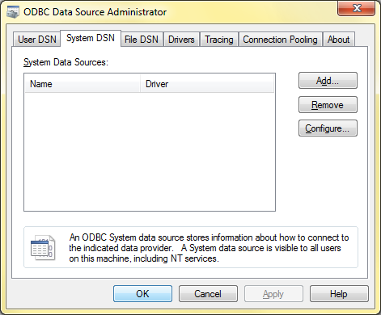

1. On the **System DSN** tab, click the **Add…** button
2. Select **PostgreSQL ANSI** as the Driver. Click the **Finish** button to open the **PostgreSQL ANSI ODBC Driver (psqlODBC) Setup** dialog
3. Enter **PostgreSQL30** as the Data Source. Enter the correct Database and Server (e.g. sola and localhost). Use the default Port: **5432.** Enter **postgres** as the User Name and enter the correct Password
4. Click the **Test** button to confirm that the connection is successful. If unsuccessful, check that the connection parameters are correct and try again

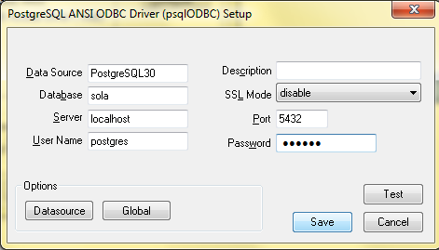

1. Click the **Save** button
2. Close the **ODBC Data Source Administrator** window

### Image Migration Parameters

Before running the Image Migration, you need to ensure that the correct parameters have been configured for the Image Migration program.

1. Open up the Image Migration program (…database\migration\images\**LRS Image Migration v#.###.accdb)**
2. If you see the Security Warning message below, then proceed to Step 3. If not, then proceed to Step 4

SecurityWarning.png

1. Click on **Options…**, then on the **Microsoft Office Security Options** window, select **Enable this content** and click the **OK** button
2. On the Navigation Pane to the left of the screen, double-click on the **Main** Module to view the source code for the program

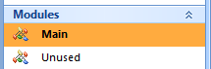

1. Ensure that the parameters for the constants are correct. DSN should be **PostgreSQL30**. UID should be **postgres**. PWD and Database should have the correct Password and Database. The value of the LOG_TABLE String should be **document.log**

CONNECTION_STRING is for the **sola** database

CONNECTION_STRING_DOCUMENT is for the **sola_document** database

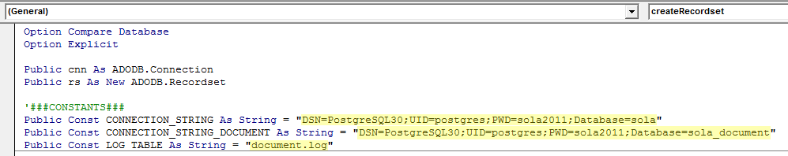

1. Save the changes and close the program

## Running the Image Migration

The following steps describe how to perform the Image Migration.

1. Open up the Image Migration program (…database\migration\images\**LRS Image Migration v#.###.accdb**)
2. If you see the Security Warning message below, then proceed to Step 3. If not, then proceed to Step 4

SecurityWarning.png

1. Click on **Options…**, then on the **Microsoft Office Security Options** window, select **Enable this content** and click the **OK** button

### Create Tables

Create the document.log and document.document_migration tables to record the details of the Image Migration

1. Click the **Create Tables** button
2. Click **OK** on the two confirmation messages that appear

### Run the Image Migration

You are now ready to run the Image Migration

1. Select the image type you are going to migrate from the **Image Type** dropdown box
2. Indicate whether you would like to load the images or blanks by checking/unchecking the **Load Images** check box
3. Click on the **Migrate LRS Images** button to initiate the Image Migration process
4. The Browse window should now be shown. Use this window to locate and select the folder containing the images you wish to migrate. Please note that all images in the folder should be of the type you selected in **Step 1**

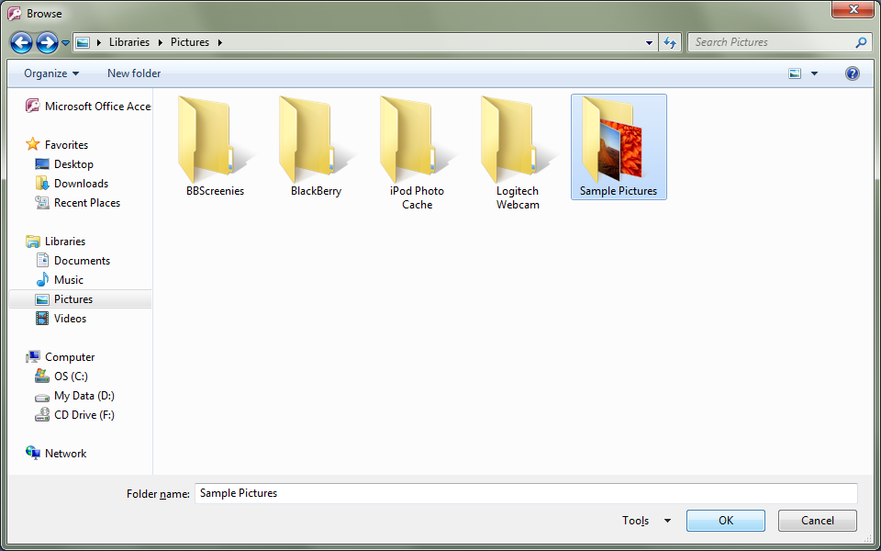

1. Once you have found and selected the correct folder, click the **OK** button to begin the migration
2. The migration process will take quite a long time depending on the number and sizes of the images to be migrated. The Image Migration program will be inactive during the migration. You can view the **document.log** table with pgAdmin III to see the status of the migration.
3. Once the migration is complete, a confirmation dialog should appear stating the Elapsed time. Click **OK**
4. Check the document.log table for any errors that might have occurred during the migration. You may have to rename some files to fix duplication errors and run a script(s) to load the remaining images that weren’t successfully loaded during the migration.

### Populate the source.source Table

Once all images have been successfully loaded into the document.document table, the final step is to populate the source.source table so that the loaded images can be found and viewed in the SOLA application.

1. Click the **Populate source Table** button
2. A confirmation dialog should appear once the table has been populated. Click **OK**
3. THE END ☺